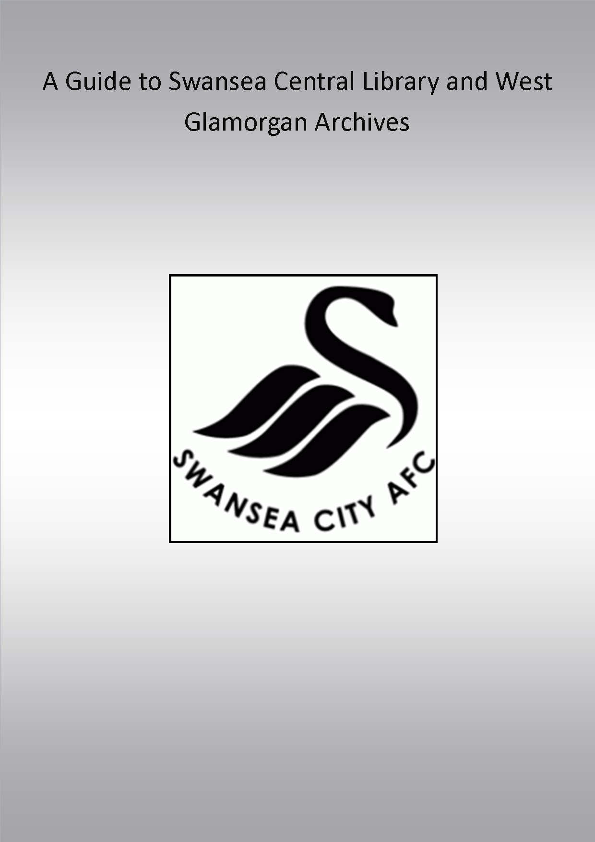

Introduction- Historical Importance
To celebrate Swansea football clubs centenary year, the Heritage Lottery are funding a project to conserve and celebrate the history of the club. Part of this project is the following document, a guide to the holdings of Swansea Central Library and West Glamorgan archives, held at the Civic Centre on Swansea’s front. An archive is a government owned facility which holds historical documents accessible to the general public. The documents in the West Glamorgan Archives are a collection of local historical documents which have been donated by private individuals as well as government records.
Documents and resources relating to football history available from libraries and archives hold key uses for Historians and fans alike. When researching or even pursuing an interest in Swansea Town /City football club both library and archive, located at the Civic Centre along the front of Swansea, hold valuable documents and books. The documents situated at the civic centre provide a variety of sources including local newspaper cuttings, programmes, photographs and handwritten season reviews, including fragments of notes from AGM’s.
The various documents can show the changes which have occurred in the history of the Swans over the past century. The press cuttings for example show the change in football and how mainstream football has changed since the rise of its commercial appeal linked with the premiership and technological advances. Separate to the Swans, the archives also hold a range of photographs and records from local school boy teams during the twentieth century, which were often linked to the club itself.
Key statistics and results from seasons are available from the archives, and the season reviews in press cuttings, show key transfers of players and can show how the Swans have evolved.
The aim of this guide is to give an overview of information relating to the Swans being held at West Glamorgan Archives. The material is listed below, however the titles and reference numbers are more guidelines and not specific to its contents with some examples. After requesting documents, there is the challenge of understanding and piecing together the contents as they are, sometimes, in a random order. The author of some documents is also hard to find with much of the reviews and documents being handwritten, however a large portion of material had been donated by David Farmer, who is mentioned in the guide several times.

West Glamorgan Archives
Address; West Glamorgan Archive Service,
Civic Centre, Oystermouth Road,
Swansea SA1 3SN
The Archives are located on the right side of the Civic Centre and the Library on the left hand side. The Archives are open 9am – 7pm on Tuesdays and 9am -5pm from Wednesday to Friday. In order to obtain the documents available within the archives, a day pass can be acquired at the archive desks, and a permanent one can be attained with proof of identification and address. Once these steps are fulfilled, it is an easy process to request the documents listed below. This is as simple as writing the code of the desired document on a request slip and giving it to the archivist’s desk. The material regarding the football club is in the Private Deposit folder labelled D219 – end.
Similarly the internet catalogue is available over the internet or at the archives for the desired topic to be researched, giving results of related topics to the keyword entered. However, it is not always reliable as the browser is relatively word specific, for example if ‘Swansea City Football Club’ is entered it will not bring the Vetch correspondence up, further searching is required.

The material held in the archives is as follows;
- D80/1-2- Swansea Town AFC Supporters Club minute books
- D219/1/1-15- Club Programmes
- D219/2/1-22-Press Cuttings
- D219/3/1-2- Photographs
- D219/4/1- Letters of Correspondence
- D219/4/2- League tables from 1920/21-1938/39 and fixtures and results between 1930/31-1939/40, 1946/7-1970/71 and 1978/79 to 1983/4
- D219/5/1- Aberdare Athletic Football Club Official Supporters Handbook
- D219/5/2- Swansea City Council F.C Year Book
- D219/5/3- Swansea City Council A.F.C Official Annual
- D219/5/4-S.C.F.C 75th Anniversary Book
- D219/5/5 Swansea city A.F.C Official Souvenir
- D219/5/6 Swansea City A.F.C A Sports Gazette Publication from Fourth to First 1978-1981
- D/D Ga/S 116/106 – Vetch Field Correspondence

Notes
It is worth noting however, that some material found amongst these files does not relate to the History of Swansea City Football Club. For example, amongst the files under the D219/5 coding, there is information on Welsh Rugby and random documents on Swansea life rather than anything relating to the club. Furthermore, the exact labels of the documents shown can be vague and not completely accurate as to what can actually be found in the files. The actual contents are specified on the description of each file within this guide.

Minute books-D80/1-2
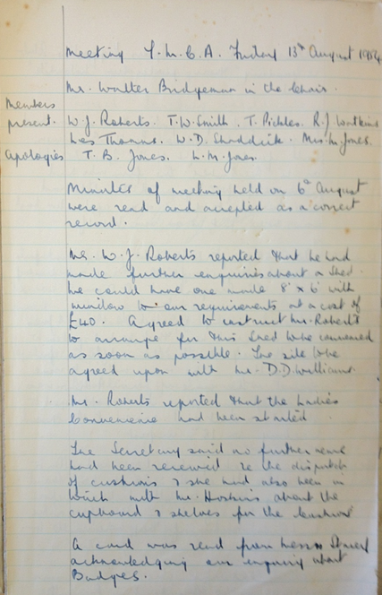
These documents are minute books kept by the Swansea Town A.F.C. Supporters Club. The minutes available in D80/1 are from the years 1954 to 1957, while the D80/2 minutes are from 1957 to 1964. A minute book is a document that contains accounts of resolutions made by a business. The minutes written down in these documents are from a weekly or fortnightly meeting between the committee members of the supporters club.
In terms of its historical significance, the minute books not only offer an insight into the history of the supporters club and Swansea Town, but also provide an understanding of the supporters club’s affiliation with Swansea Town and the Swansea community during the 1950s and 1960s. During this period, the supporters club had several functions both within the club and the local community.
Part of the supporters club’s role was to assist and improve the football club. This can be seen in the form of financial donations being provided to the Swansea Town board. The supporters club was able to donate a total of £25,000 for Swansea Town between 1953 and 1963. Donations were greatly used to improve the Vetch Field stadium. This included the funding of the building of a roof for the North Bank with a donation of just over £13,000. A contribution was also made for the instillation of flood lights at the ground. Similarly to the modern Swansea City supporters club, the Swansea Town supporters club possessed a substantial number of shares in the football club, owning £441 worth of shares in 1962. The supporters club also organised the football pools competition for several years from 1957 due to the FA’s refusal to allow football clubs to run the competition. Auxiliary bodies had to be found leading Swansea Town to use the supporters club. The role the supporters club had with aiding the football club appears to have been more significant than the role of its modern counterpart.
The supporters club had various roles within the local community. There is evidence of a social involvement which included dinner dances being arranged at Brangwyn Hall by the committee and they also provided members with the opportunity to meet Swansea Town players. Economic aid can be seen being provided, with the minutes showing that the supporters club carried out collections at the Vetch Field for various institutions that asked for assistance as well as providing their own donations to charities. The supporters club also carried out duties that benefited fans. Examples of this include arranging transport for the away games, organising half time competitions and selling match day programmes. The club also donated equipment and money to local school football teams.
Another use for this document is to see how successful the supporters club was as a business during this period. This information can be gained from the minutes for the annual meetings held at the end of the football season where a financial report is given and the social success of the club over the year is assessed. The previous importance of the FA Cup is also shown through the club’s annual meeting in 1964, the year Swansea equalled their best run in the Cup but eventually succumbed to Preston North End in the semi-final held at Villa Park. During the 1963-64 season, the supporters club’s membership and revenue increased significantly on the back of the Swans cup run and the away fixtures that came with it.
There are however problems that can be encountered when researching these documents. As minute books, the contents of what is written down by the minute taker mainly states what decisions were made rather than what was discussed during the meeting. As a result, this limits the amount of detail that can be extracted from the meetings. The minutes that are written down are often brief which means a full understanding of the decisions that were made are unable to be obtained. We are also not informed of disagreements between the members or of other options that the club had open to it. Another issue is the handwriting of the minute taker which at times may be difficult for some readers to understand. It therefore, can make it harder to acquire information from the documents and also means some important events could be missed by the reader. This is however negated by the annual meetings where the most important events are written down.

Match Programmes-D219/1/1-15
A football match programme is a programme that is purchased by fans during match day at the home team’s ground which provides various articles relating to the match as well as news from the club.
The match programmes in these boxes are a combination of league games, domestic cup games such as the Welsh Cup and F.A Cup along with European cup Winners Cup games ranging from the years 1945 to 1992. As time progresses the aesthetics of the programme changes along with new added material such as the introduction of games.
In these programmes which are named ‘The Swan’, there is a variety of content. Each match programme begins with a paragraph from the manager and occasionally the chairman. These paragraphs provide a word on recent performances as well as giving a bit of information on the opposition team.
There is a page given to the Supporter’s club and the Friends of Swansea City Football Club Association (FOSCFA) where they provide news on travel for away fixtures for the fans as well as news on upcoming events that they have organised.
The programmes also contain numerous adverts from local businesses and sporting brands who are attempting to promote their company to the fans. Examples of these include Mitre, Savage Motors Ltd and Valmatics Ltd Amusement machines. In some programmes the kit sponsorship for individual players is provided and it also offers the opportunity for businesses to sponsor players and get their brand name on an item of kit.
An article is written on the opposition team which focuses on their history as well as assessing their current performances. An analysis of the opposition team and their manager is also provided along with a squad photo.
Radio Vetch is also given an article where they discuss general issues in world football as well as issues particularly relevant to Swansea City.
A team sheet is also provided on the back page of the programme so fans can see which players will be starting in the game before the match begins.
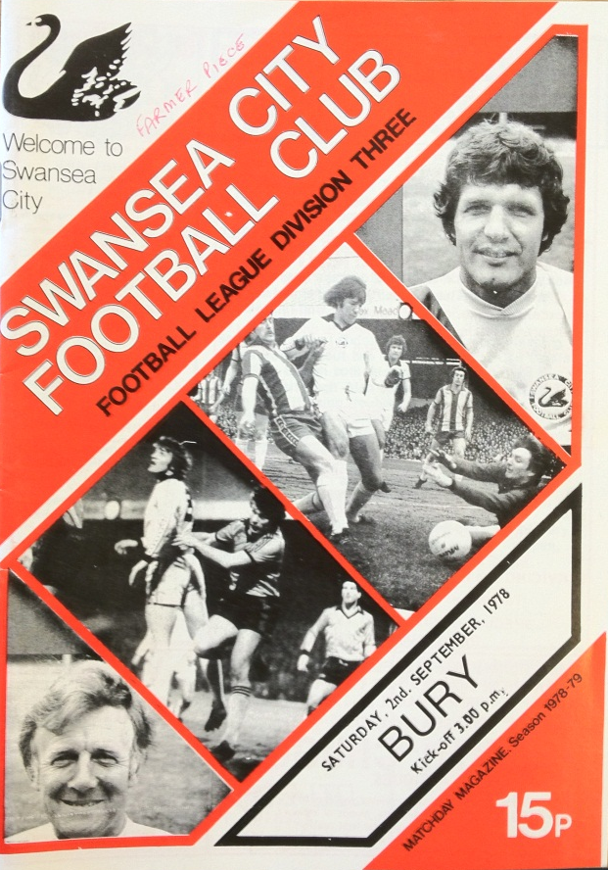
The historical significance of match programmes is that they provide a chronicle of a period in the club’s history. By reading match programmes the reader is able to understand or remember how successful Swansea was and the club’s situation at a particular period in time. It also provides the reader with information on previous players and managers that were employed by the club that may have been forgotten by some supporters. Statistical data can also be obtained from match programmes as they provide facts on Swansea’s performance during that season. This includes information on previous results, goal scorers, appearances and the league table at that time. There are a couple of programmes that are from away games meaning that the opposition has written the programme instead of Swansea. As a result it provides the reader with the opposition’s opinion of Swansea’s recent performances and looks at Swansea’s success in earlier years.
Furthermore, this gives an insight to the donator of the programmes, and their keen support by travelling when possible to away match. Programmes can also be used to look at what methods businesses used to advertise from 1978 to 1991.
As an example of the contents of the boxes, D219/1/1 contains the match programmes for the following games:
Programmes for Swansea City v the following sides: Aldershot: 30 Sep. 1986. 17 Feb. 1989; Arsenal: 26 Aug. 1980. 27 Feb. 1981. (2 Copies) 10 Oct. 1981. (a) 20 Dec. 1982; Aston Villa: 15 Dec. 1981. 2 May 1983; Bangor City: 16 Mar. 1982. (a) 20 Apr. 1982; Barry Town: 18 Apr. 1989. 18 Apr. 1991; Bognor Regis: 17 Nov. 1984; Caersws: 17 Jan. 1989. 31 Jan. 1989 (a); Colwyn Bay: 5 Mar. 1991; F.C.Lokomotiv Leipzig: 16 Sep. 1981; Hayes: 14 Nov. 1987 (a); Hillingdon Borough: 25 Nov. 1978; Kidderminster Harriers: 25 Feb. 1980. 21 May 1989; Leyton Wingate: 16 Nov. 1985; Llanelli: 30 Oct. 1990; Magdeburg: 24 Aug. 1983; Merthyr Tydfil: 12 Jan. 1988. 7 Nov. 1989; Monaco: 17 Sep. 1991; Panathinaikos: 27 Sep. 1989; Paris St. German: 20 Oct. 1982; Red Star Belgrade: 14 Feb. 1981; Sliema Wanderers: 15 Sep. 1982; Slough: 6 Dec. 1986; Sporting Braga: 17 Aug. 1982; Wealdstone: 18 Nov. 1986; Welling United: 17 Nov. 1990; Worcester City: 11 Dec. 1981. 1978-1991
D219/1/2-1973-1992
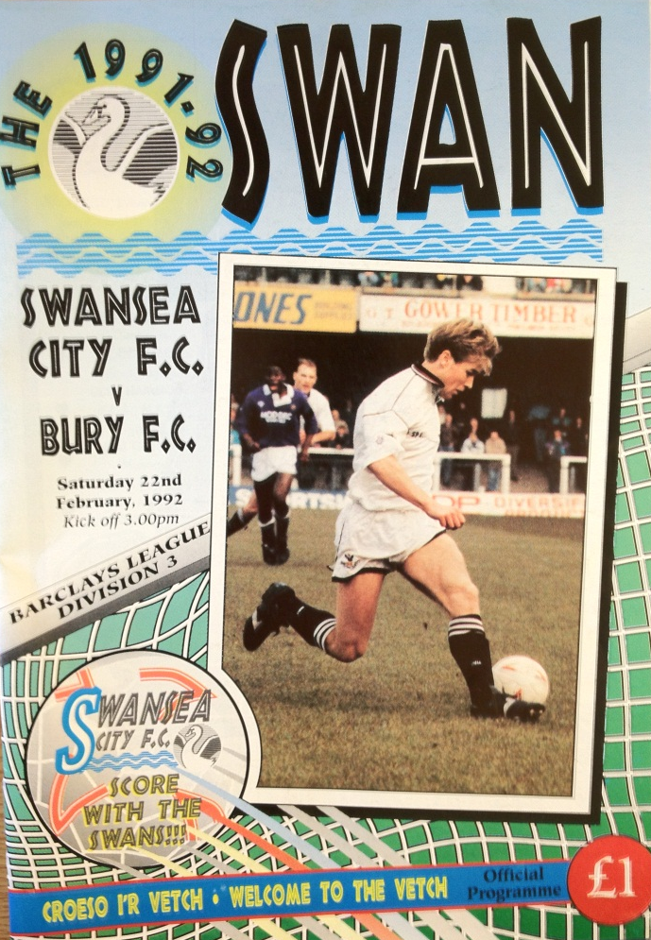
Programmes for Swansea City v the following sides: Barnsley: 27 Oct. 1981. 19 Mar. 1984; Birmingham City: 14 Sep. 1973, 29 Feb. 1980 24 Apr. 1981. (a) 28 Nov. 1981. 29 Dec. 1982. 2 Apr. 1983 13 Feb. 1990. 1 Dec. 1990. 18 Jan. 1992; Blackburn Rovers: 4 Apr. 1981. 29 Oct. 1983; Blackpool: 11 Jan. 1986. 13 May 1989. 2 Dec. 1989; Bolton Wanderers: 28 Feb. 1981. 18 Feb. 1984. 8 Feb. 1986 18 Mar. 1988. 5 May 1990. 4 May 1991. 24 Aug. 1991; Bournemouth: 11 Aug. 1979. 14 Aug. 1979. (a) 12 Feb. 1985 1 Jan. 1986. 1 Aug. 1989. 9 Mar. 1991. 8 Nov. 1991. 1973-1992
D219/1/3-1978-1992
Programmes for Swansea City v the following sides: Bradford City: 15 Sep. 1984. 9 Apr. 1991. 28 Mar. 1992; Brentford: 17 Nov. 1945. 19 Nov. 1977. (a) 17 Nov. 1982 22 Sep. 1984. (a) 9 Feb. 1985. 8 Mar. 1986. 30 Dec. 1989. 15 Sep. 1990 11 Feb. 1992; Brighton & Hove Albion: 1 Sep. 1981. (a) 24 Nov. 1981 10 Sep. 1983; Bristol City: 17 Mar. 1981. 12 Mar. 1985. 23 Nov. 1985. 3 Feb. 1989 20 Mar. 1990; Bristol Rovers: 5 Apr. 1980. 26 Oct. 1982. 22 Dec. 1984. (a) 22 Jan. 1985. 19 Mar. 1985. (a) 11 May 1985. 28 Sep. 1985 7 Dec. 1985. 31 Dec. 1988. (a) 8 Apr. 1989. 25 Nov. 1989. (a) 24 Feb. 1990; Burnley: 4 Apr. 1985. 6 Feb. 1987. 6 Feb. 1988; Bury: 2 Sep. 1978. 2 Nov. 1985. 23 Mar. 1990. 18 Sep. 1990. 22 Feb. 1992. 1978-1992
D219/1/4-1979-1992
Programmes for Swansea City v the following sides: Cambridge United: 6 Oct. 1979. (a) 14 Mar. 1980 30 Aug. 1980. 24 Sep. 1983. 1 Mar. 1985. 4 Nov. 1986 11 Apr. 1987. (a) 3 Oct. 1987. 3 Nov. 1990; Cardiff City: 1 Jan. 1980. 18 Apr. 1981. 19 May 1982 21 Apr. 1984. 3 Sep. 1985. 26 Dec. 1985. (a) 31 Mar. 1986 20 Apr. 1987. 1 Jan. 1988. 26 Dec. 1988. (a) 27 Mar. 1989 26 Mar. 1989. 16 Apr. 1990. (a) 16 Nov. 1991. 19 Nov. 1991 18 Feb. 1992; Carlisle United: 5 Nov. 1983. 12 Dec. 1987; Charlton Athletic: 8 Dec. 1979. 3 May 1980 (a) 25 Feb. 1984; Chelsea: 26 Apr. 1980. 25 Apr. 1981. 22 Nov. 1983 27 Jan. 1989. 19 Aug. 1988; Chester City: 10 Mar. 1989. 9 Sep. 1989. 24 Nov. 1990 26 Dec. 1991. 1979-1992

D219/1/5-1979-1990
Programmes for Swansea City v the following sides: Chesterfield: 11 May 1979. 5 Nov. 1985. 17 Dec. 1988; Colchester United: 4 Oct. 1983. 20 Dec. 1986 24 Apr. 1987. (a) 13 Dec. 1988; Coventry City: 24 Oct. 1981. (a) 13 Mar. 1982 31 Aug. 1982; Crewe Alexandra: 21 Feb. 1987. 26 Sep. 1987 7 Oct. 1989. 13 Oct. 1990; Crystal Palace: 5 Jan. 1980. 3 Dec. 1983. 11 Aug. 1989. 1979-1990
D219/1/6-1979-1992
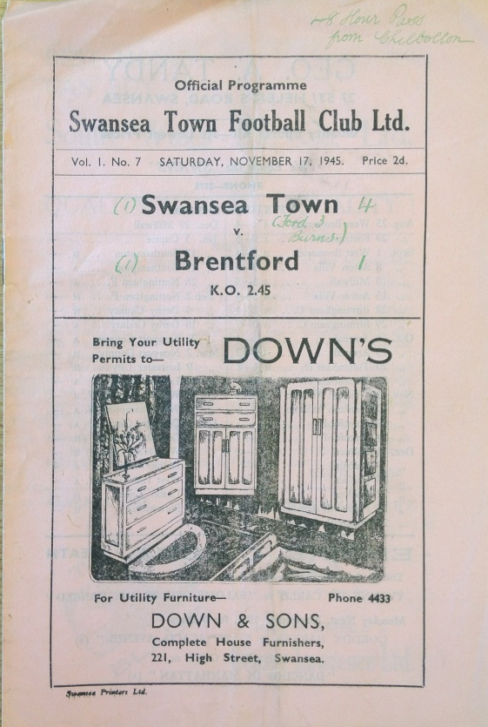
Programmes for Swansea City v the following sides: Darlington: 12 Apr. 1986. 7 May 1988. 28 Jan. 1992; Derby County: 11 Oct. 1980. 31 Dec. 1983. 29 Dec. 1984 6 May 1986; Doncaster Rovers: 19 May 1985. 22 Oct. 1985; Everton: 1 May 1982. 16 Oct. 1982; Exeter City: 1 Jan. 1987. 22 Aug. 1987. 29 Aug. 1989 26 Feb. 1991. 14 Dec. 1991. 17 Dec. 1991; Fulham: 13 Oct. 1979. 5 Feb. 1984. 4 Mar. 1989. (a) 10 Feb. 1990. 20 Oct. 1990. 4 Apr. 1992. 1979-1992

D219/1/7- 1979-1992
Programmes for Swansea City v the following sides: Gillingham: 16 Mar. 1979. 29 Sep. 1984. 22 Mar. 1986 27 Aug. 1988. (a) 19 Mar. 1989; Grimsby Town: 24 Oct. 1980. 19 Nov. 1983. 23 Mar. 1991; Halifax Town: 27 Mar. 1987. 23 Jan. 1988; Hartlepool United: 22 Nov. 1986. (2 copies) 31 Aug. 1987. 28 Apr. 1992; Hereford United: 4 May 1981. 11 May 1981. (a) 27 Feb. 1985. 2 Sep. 1986. 27 Dec. 1986 (2 copies) 12 Sep. 1987; Huddersfield Town: 18 Jan. 1984. 22 Mar. 1989. 21 Jan. 1990. ' 1 Sep. 1990. 25 Apr. 1992; Ipswich Town: 7 Nov. 1981. (a) 27 Mar. 1982. 30 Apr. 1983; Hull City: 5 Mar. 1985. 3 Feb. 1987. 11 Oct. 1991. 1979-1992
D219/1/8- 1979-1990
Programmes for Swansea City v the following sides: Leeds United: 29 Aug. 1981. 7 May 1984; Leicester City: 29 Sep. 1979. 23 Sep. 1986; Lincoln City: 9 May 1987; Liverpool: 16 Feb. 1982. 18 Sep. 1982. 6 Jan. 1990. (a) 9 Jan. 1990. 27 Jan. 1990; Luton Town: 18 Jan. 1980. 4 Mar. 1980. 21 Mar. 1981 17 Apr. 1981. 4 Dec. 1982. 23 Apr. 1983. (a). 1979-1990
D219/1/9- 1981-1990
Programmes for Swansea City v the following sides: Manchester City: 17 Apr. 1982. 12 Mar. 1983. 7 Apr. 1984; Manchester United: 30 Jan. 1982. 18 Dec. 1982 13 Jan. 1986; Mansfield: 8 Nov. 1988. 10 Mar. 1990. 23 Feb. 1991; Middlesbrough: 3 Jan. 1981. 15 May 1982. 27 Apr. 1984; Millwall: 26 Mar. 1985. 1981-1990
D219/1/10- 1979-1989
Programmes for Swansea City v the following sides: Newcastle United: 24 Nov. 1979. 15 Oct. 1983; Newport County: 17 Mar. 1985. 17 Sep. 1985. 20 Jan. 1986 16 Feb. 1986. (a) 11 Nov. 1986. 17 Oct. 1987; Northampton Town: 20 Sep. 1986. 14 Feb. 1987. (a) 19 Nov. 1987. 26 Aug. 1989. 4 Sep. 1982; Nottingham Forest: 12 Dec. 1981. 14 May 1983; Nott’s County: 9 Feb. 1980. 13 Sep. 1980. 12 Sep. 1981 28 Aug. 1982. (a) 15 Jan. 1983. 26 Apr. 1986. 7 Jan. 1989 30 Sep. 1989. 1979-1989
D219/1/11- 1979-1991
Programmes for Swansea City v the following sides: Oldham Athletic: 27 Oct. 1979. 7 Oct. 1980; Leyton Orient: 21 Dec. 1979. 8 Nov. 1980. 6 Oct. 1984 6 Sep. 1986. 24 Oct. 1987. 3 Apr. 1990. 18 Jan. 1991. 30 Apr. 1991 5 Nov. 1991; Peterborough United: 17 Mar. 1987. 21 Nov. 1987 9 Dec. 1989. 28 Sep. 1991; Plymouth Argyle: 1 Dec. 1984. 26 Aug. 1985; Portsmouth: 17 Dec. 1983; Port Vale: 29 Apr. 1989; Preston North End: 29 Dec. 1979. 2 May 1991. (a) 30 Mar. 1985. 16 Jan. 1987. 29 Oct. 1989. 11 Nov. 1989 16 Apr. 1991. 14 Sep. 1991. 1979-1991
D219/1/12- 1979-1991
Programmes for Swansea City v the following sides: Queens Park Rangers: 3 Oct. 1978. (a) 15 Sep. 1979 31 Jan. 1981; Reading: 26 Jan. 1980. 10 Nov. 1984. 13 Apr. 1985 (a) 22 Feb. 1986. 2 Jan. 1989. 23 Sep. 1989. 17 Jan. 1990 22 Dec. 1990. 3 Sep. 1991; Rochdale: 1 Nov. 1986 (2 Copies), 2 Apr. 1988; Rotherham United: 26 Dec. 1984. 7 Sep. 1985 15 May 1988. 31 Oct. 1989. 1 Jan. 1991. 5 Jan. 1991; Scunthorpe United: 11 Oct. 1986. 30 Apr. 1988; Scarborough: 16 Jan. 1988. 1979-1991

D219/1/13- 1979-1992
Programmes for Swansea City v the following sides: Sheffield United: 3 Dec. 1988; Sheffield Wednesday: 20 Sep. 1980. 27 Aug. 1983; Shrewsbury Town: 18 Aug. 1979. 25 Mar. 1980. 19 Aug. 1980 17 Dec. 1983. 14 Apr. 1990. 27 Nov. 1990. 27 Apr. 1991 17 Apr. 1992; Southampton: 23 Sep. 1980. 28 Dec. 1981. (a) 23 Aug. 1982. 4 Aug. 1989; Southend United: 31 Jan. 1987. 21 Jan. 1989 12 Mar. 1991; Stockport County: 23 Aug. 1986. 19 Feb. 1988 28 Dec. 1991; Stoke City: 17 Oct. 1981. (a) 6 Mar. 1982 16 Apr. 1983. 4 Sep. 1990. 30 Mar. 1991. 19 Oct. 1991; Sunderland: 10 Nov. 1979. 26 Sep. 1981. 6 Nov. 1982; Swindon Town: 13 Aug. 1988. 1979-1992
D219/1/14- 1979-1992
Programmes for Swansea City v the following sides: Torquay United: 19 Feb. 1986. 7 Apr. 1987 28 May 1987. (a) 28 Dec. 1987. 25 May 1988. 8 Feb. 1992; Tottenham Hotspur: 29 Aug. 1978. 6 Sep. 1978. (a) 8 Aug. 1980. 22 Sep. 1981. 2 Oct. 1982. 25 Sep. 1991; Tranmere Rovers: 3 Apr. 1987. 9 Apr. 1988. 20 Oct. 1989 28 Sep. 1990; Walsall: 28 Aug. 1984. 20 Oct. 1984. 21 Dec. 1985 9 Dec. 1986. 7 Apr. 1990. 8 Dec. 1990. 20 Aug. 1991; Watford: 13 Jan. 1979. 9 Oct. 1979. 16 Dec. 1980; West Bromwich Albion: 9 Jan. 1982. 26 Mar. 1983 10 Jan. 1987. 6 Mar. 1992. 1979-1992
D219/1/15- 1980-1992
Programmes for Swansea City v the following sides: West Ham: 16 Feb. 1980. (a) 29 Mar. 1980. 10 Jan. 1981 26 Dec. 1981. 10 Apr. 1982. (a) 5 Apr. 1983. 8 Oct. 1985; Wigan Athletic: 3 Nov. 1984. 17 Aug. 1985. 15 Apr. 1989 21 Apr. 1990. 6 Apr. 1991. 14 Mar. 1992; Wolverhampton Wanderers: 31 Oct. 1981. 25 Jan. 1986 18 Oct. 1986. 27 Oct. 1987. 3 Nov. 1987. 24 Sep. 1988; Wrexham: 12 Apr. 1980. 6 Mar. 1981. 10 May 1983. (a) 17 May 1983. 2 May 1987. 10 Oct. 1987; York City: 1 Sep. 1984. 14 Dec. 1985. 1980-1992

Press cuttings- D219/2/1-22
While the files labelled ‘press cuttings’ contain mostly news articles and match programmes in the later dated files, the earlier files contain a great deal of notes apparently written by members of the board of directors, along with statistics sheets. The dates of files available are listed below:
- 2/1 1921-1939
- 2/2 1939-1960
- 2/3 1960-1977
- 2/4 1977-1979
- 2/5 1979-1980
- 2/6 1980-1981
- 2/7 1981-1982
- 2/8 1982-1983
- 2/9 1983-1984
- 2/10 1984-1985
- 2/11 1985-1986 (Part 1)
- 2/12 1985-1986 (Part 2)
- 2/13 1986-1987
- 2/14 1987-1988
- 2/15 1988-1989
- 2/16 1989-1990
- 2/17 1990-1991
- 2/18 1991-1992
- 2/19 1992-1993
- 2/20 1993-1994
- 2/21 1994-1995
- 2/22 1995-1966
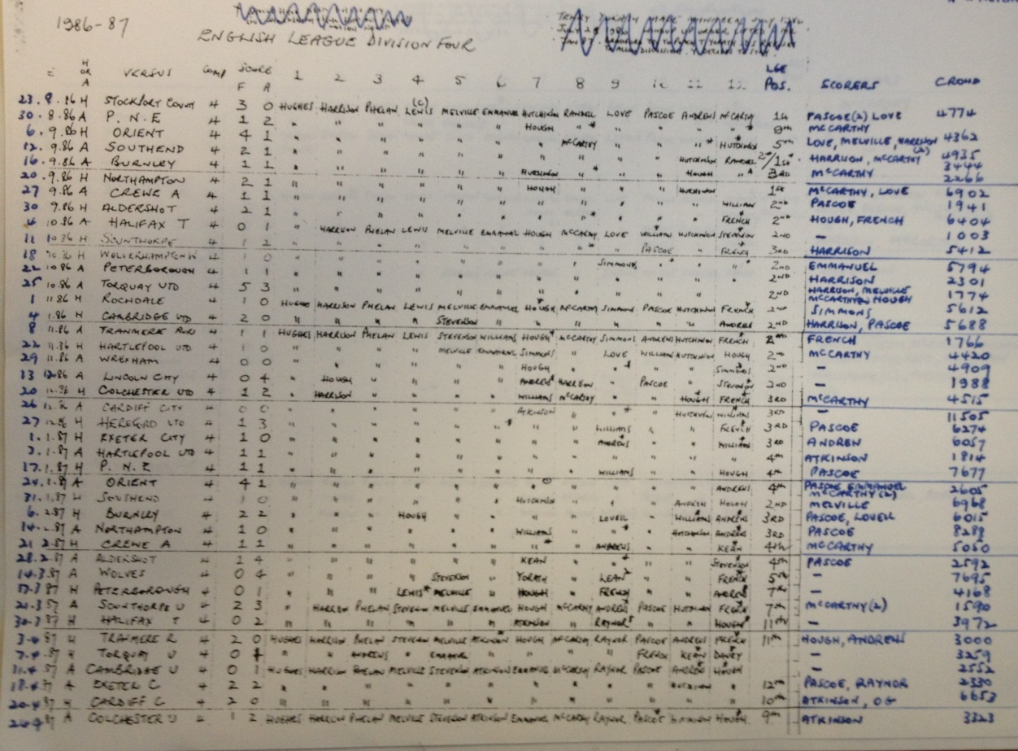

Arguably the most interesting files amongst these collections are the first two, D219/2/1-2 due to their age and how they are far more unique than the later files. The first files contains a season based review in note form similar to the previous files which includes key events from the seasons such as transfers, expenditure and various club developments. The author of these reviews is unknown but is likely to have been a board member or a supporter’s club representative as the notes contain brief reviews of minutes from Annual General Meetings(AGM’s).
They mainly take a similar layout, being divided in to one season per folder. The first document of each folder is a fixtures list, written apparently at the end of the season. This list includes dates of fixtures, results, attendance lists and estimated gates. After this, there are usually a number of hand-written documents, varying between roughly seven and thirty-five documents per season, noting a variety of topics concerning the club. While quite brief in form, these notes cover a variety of issues, such as acceptances of proposed line-ups for upcoming games, reports on the team’s form, expenditure reports and records of transfers. At the end of each folder there is a season review, detailing results, goal scorers, record wins and losses, along with the end of season league tables. What is of great use for historical research is the information recorded in the records from the early 1920’s detailing low attendance figures. One document, dated 18 February 1922, provide explanations for the low attendances, describing the economic troubles facing South Wales at this time. This is useful because it gives an insight in to the effects that economic troubles have on the game, along with insights in to the social history of football fandom in Swansea. This can show the type of fans that football attracts, largely working class in nature, where there is less financial freedom.
The press cutting holdings are separated into separate year sections depending on the amount of material for each yearly period. This box, D219/2/2 for example is split over a 19 year period from 1921 to 1939, whilst the more recent files are split from 1979 to 1996 by just one file. This in itself tells the story of how the material from the earlier stages of Swansea football club is extremely hard to find, and not existing in this example of the archives.
The second file within the box specifically contains an eight page season summary. The difficulty with these files is deciphering the handwriting; however the notes provide an interesting outlook of the club post war. H. Green is said to have made an appeal to supporters for ‘an odd tablet or two’ of soap due to a shortage at the Vetch. This fits in with the imagery of the infamous Vetch toilets facilities, or lack of, along with the rationing of commodities that took place in Great Britain during this period.
Furthermore there were noted problems getting large crowds to attend the games which was an aim of the board to improve. H. Green is noted to have had the ambition to have a large roof over the main bank, something which was implemented in the late 1950’s. This gives an insight to the ambition, or what was seen as key steps in the clubs survival and development.
Another interesting document is a speech made by Abe Freedman, one of the original members of the board of directors, where he stated the aim to increase accommodation to near 60,000 in Swansea, pulling in larger crowds and being able to support travelling supporters from both sets of fans. This is clear example of how the football club aimed to progress but also help stimulate the local economy, a parallel like which we can see in the clubs premiership era.
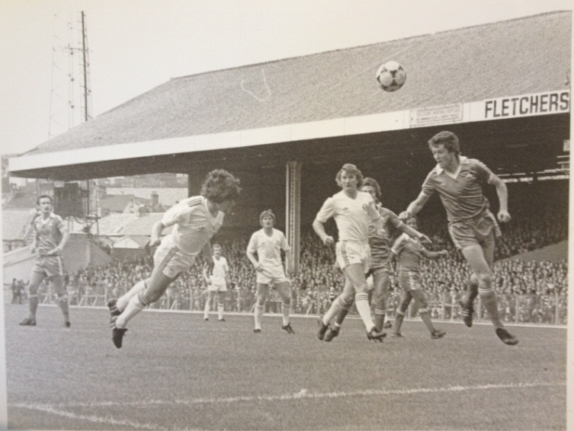

Photo Bundle- D219/3/1&2
These two bundles of photographs and postcards covers roughly 70 years from the club’s early seasons in the Southern League to the glory years of the early 1980’s. The oldest items are postcards and negative photographs from the club’s short period of competitive football between its formation in 1912 and the suspension of league football due to the First World War in 1915. Squad photos from selected seasons in the 1910’s, 50’s, 60’s, 70’s and 80’s are in the bundle, some of which list the players. The most numerous pictures are those of former players. The collection covers a large timespan enabling the observer to see some of the changes the club and the game of football have gone through from stadium requirements to the evolution of the football kit. Many of these once belonged to the late David Farmer, former president of Swansea City. The second file is labelled line drawings in the archival catalogue however it is in fact a continuation of the first photograph file, with some repeats.

Letters of Correspondence relating to the club-D219/4/1
The Correspondence folder located in the West Glamorgan Archives is a source of fantastic historical documents, largely written between 1979 and 1988. The vast majority of the documents in the folder concern the late David Farmer, former historian and president of Swansea City FC, who passed away in November 2010.
These documents, largely letters of correspondence written both to and from Mr Farmer, concern his research for his book Swansea Town/City 1912-1982 and the Swansea City yearbook he wished to compile in celebration of Swansea City’s 75th Anniversary in 1987. The research contains a number of letters, namely letters directed to Mr Farmer from Deadwood Publishing in Swansea concerning publishing costs of his book, and letters to the South Wales Evening Post requesting permission to use photos of the team for the book. There is also a large letter, dated 14th April 1980 from Chairman Malcolm Struel, enclosing a manuscript for research of Success is the Name of the Game by Brinley E. Matthews. Also included is a short bibliography of other clubs history books, useful for those interested in further study of footballing history in Great Britain. A large section of the folder contains a number of photocopies of the book 100 Years of Welsh Soccer.
- Note written by Mr Farmer reviewing Swansea City FC’s 1986/7 season
- Season review written by Mr Farmer reviewing Swansea City FC’s 1987/88 season – includes player reviews, namely Sean McCarthy
- Letter written by David Farmer discussing financial difficulties in the club and measures taken by the community to tackle them – Recipient unknown
- Player statistics for 1986/87 season, including player names, height and weight, age, appearances and goals scored
- List of Swansea City FC players who achieved a cap for the Wales national team while at the club
- Folder labelled ‘finished stats material’ – includes list of managers, leading goal scorers, record attendances etc.
- Statistics concerning Blackburn Rovers and West Bromwich Albion compiled by Mr Farmer
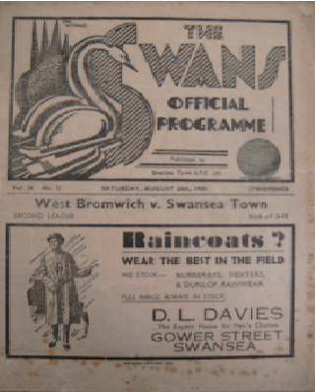
- Letters of thanks written by John F. Helliar (West Ham United’s programme manager) to David Farmer for his contribution to Mr Helliar’s programme.
- Various press cuttings from the Sports Gazette of articles written by Mr Farmer, largely match reports
- Draft copies of newspaper reports written by Mr Farmer - undated
- Letter to Mr Farmer enclosing a press cutting from 8th September 1925, including a league table and pictures of the Swansea City team on their tour of Denmark – source unknown
- Match programme for Swansea Town FC vs. West Bromwich Albion, dated 26th August 1939
- Various sociological and demographic reports concerning Swansea and the South Wales region – includes population numbers, prominent professions, key economic exports etc.
The letter concerning financial problems is a great source for those studying football clubs as a representative of a community and fandom, as it shows the commitment that the fans as a collective would go to in order to save their club.
The statistics form relating to fellow clubs and the letters from Mr Helliar are of great use for research concerning ‘legends’ of football clubs, as it demonstrates the respect and reputation that individuals such as David Farmer hold in the footballing community, and not exclusively at their own clubs.
There are also a number of sociological and demographic reports on Swansea and the South Wales region as a whole, including the percentages of the population belonging to each social class, prominent professions in the region and economic exports such as copper in Neath. They may also be potentially useful for studying a potential correlation between football fandom and social class.

General Swans Material-D219/4/2
Note-In listings as File containing league tables, fixtures and Results. However the file is labelled General Swans Material, a more apt description.
This resource contains a variety of material relating to Swansea Town AFC from 1912 to 1921. There are a number of historical uses for this material. Some of the documents accessible provide detailed statistics of Swansea’s games and seasons during the early years of its existence. A few of the documents are personal letters to and from the Swansea Town directors which helps enable the reader to understand how the negotiations over the leasing of the Vetch Field were completed. It also offers the reader with a contemporary view from the media of what they thought of Swansea Town and how they portrayed them.
The following documents are available for viewing:
- Match data from particular games during the 1920/21 season when Swansea Town played in Football League Division Three. This data is in the form of tables and contains information such as team line-ups, goal scorers along with the minute they scored, attendance and where the game was played. There are also brief comments on significant events that occurred during the game as well as the performance of both teams.
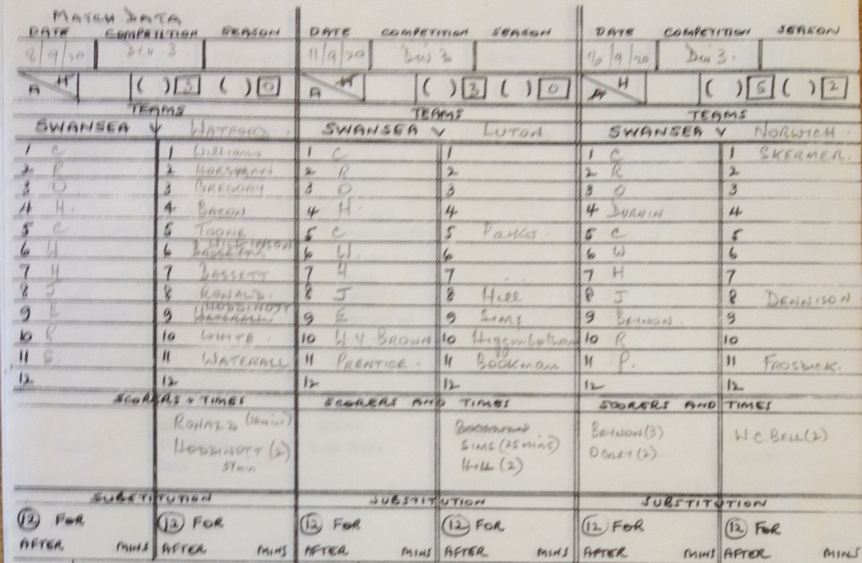
- Three photocopies of pages relating to Swansea Town from the newspaper ‘The Sporting News’. In the pages dated May 2nd 1914 there is an article that focuses on how association football has grown to become successful in Swansea since its introduction in 1912. The pages dated June 28th 1919, provide information from an annual report on the Swans from Swansea Town chairman, Mr B. Watts Jones at the general meeting of the shareholders. In an article from the pages dated May 1st 1920, a reporter focuses on Swansea’s recent performances as well as providing a fixture list and a league table. Alongside these photocopies, there are notes made by reporters who work for ‘The Sporting News’ for Swansea Town articles.
- Paper cuttings from two unknown newspapers. One is an article on how the Swansea Gas Light Company was refused permission to build a gas plant on the Vetch Field by the government and as a result, led to Swansea Town renting it from the Gas Company and turning it into a football ground. The limitation of this piece of material is that it lacks a date, meaning it is unknown when the article was written. The second article written in 1919 is about the expectation that negotiations between Swansea Town and the Gas Light Company over the renewal of the lease on the Vetch Field will be successful.
- A list of season signings made by Swansea Town in the seasons 1919, 1920 and 1921.
- Statistics for the seasons 1912/13, 1913/14, 1914/15, 1919/20 in Southern League Division Two and 1920/21 in Football League Division Three. This includes opponents played, results, team line-ups and attendance records.
- Letters received and sent by the Swansea Town directors regarding the extension of the lease of the Vetch Field, as well as the possibility of increasing the size of land being leased. There is also a statement that shows the dates that Swansea Town paid rent for the lease of the Vetch Field and how much they paid.

D219/5/1 is Aberdare Athletic Football Club Official Supporters Handbook from 1923/24, and although it is not about Swansea Town FC, it still shows interesting pictures and information for football in the post first world war period as it discusses the football clubs history.
D219/5/2 is listed in the archival records as Swansea City Council F.C Year Book. However it is not present within the box of documents in the archives. The Following documents however are present.

Swansea City Official Annual 1980- D219/5/3
The annual contains written works from the chairman Malcolm Struel, stating the challenge which the club would face in the second division the following season, along with how well the Swans had done in achieving promotion Furthermore, expenditure is an interesting factor of the document. The newly installed floodlit system had been installed effectively; however a further £700,000 or more would be needed for a new grandstand over the East Bank.
Furthermore, increasing seating capacity from 4,000 to 10,000 was seen as an important development. Along with these finances, 130,000 pounds had been received in revenue from season tickets, which was a substantial amount of money at this time. The annual also contains;
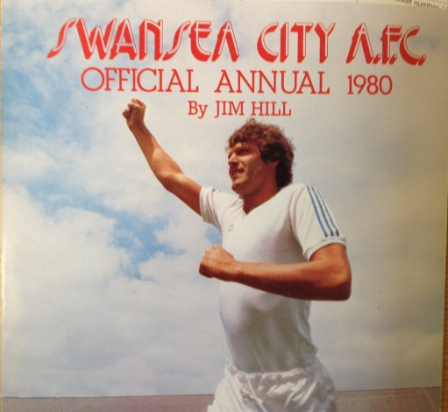
- The players-profiles and descriptions of their times at Swansea
- Player of the Year-Alan Waddle
- Young Player of the Year-Nigel Stevenson
- Coach and backroom staff information and interviews
- Les Chappell- Youth Coach
- Terry Medwin-Assistant Manager
- Gordon Daniels- Secretary
- Dave Williams Physiotherapist
- Hall of Fame players such as Ivor Allchurch & Harry Griffiths
- Article of ‘How to marry a soccer star’ by Virginia Hill
- Season review

S.C.F.C 75th Anniversary Book-1987-D219/5/4
This document is the planned draft of the 75th anniversary rather than the published version. This document is interesting as it shows specific numbers in the costs of advertising within the book, printing and publishing. The document itself contains the following:
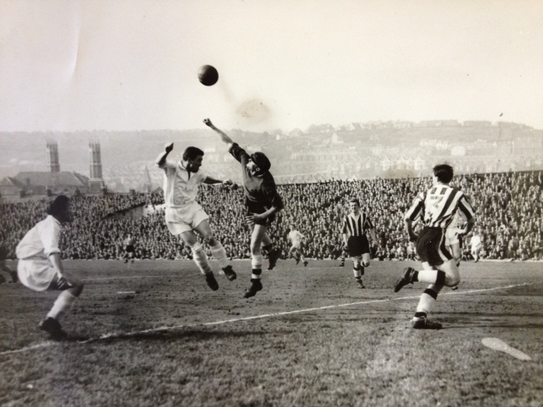
- Sketches of artwork design for the front cover
- Page layout and advertisement space.
- Written confirmation of the South Wales Evening Post purchasing advertisement spacing alongside other local companies.
- Written correspondence between printing companies
- Notes of costs, with minimum revenue of £8000 needed to cover the costs.

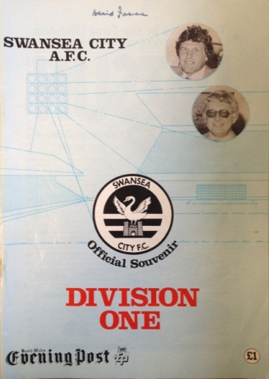
Swansea city A.F.C: official Souvenir- D219/5/5
The official souvenir was published, with the sponsorship of the evening post, in order to celebrate Swansea’s rise to the first division from the forth. The Chair of the Board, Malcolm Struel, also highlights the importance of the promotion to the first division and its implications economically being positive.
Malcolm Struel states that even non-fans would benefit, similarly to the effects the Premier League has had on Swansea. The souvenir captures the same level of excitement experienced by Brendan Rodger’s team becoming the first Welsh Club to earn promotion into the Premier League. The souvenir also includes documents from David Farmer, mentioned in the correspondence section of the guide. These include club statistics, similar to those in the press cuttings, hinting he may be the author of the result sheets within these reviews. The other contents of the souvenir are a season review from 1980, including statistics, fixtures and photos.

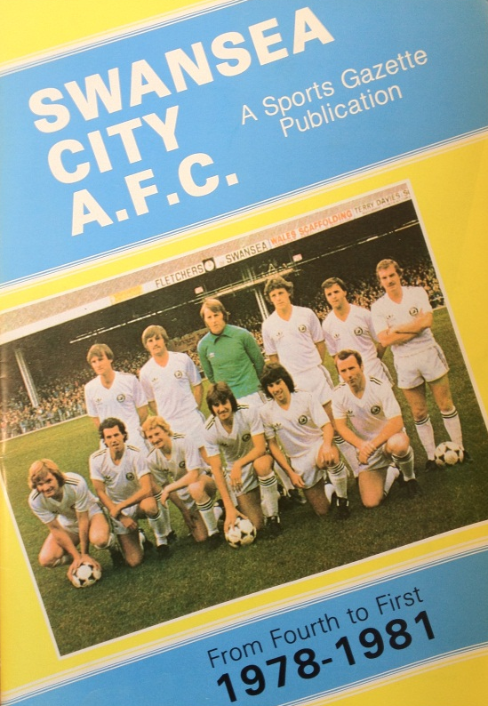
Swansea City.A.F.C A sports Gazette Publication from Fourth to First 1978-1981-D219/5/6
This document is a celebratory Sport Gazette magazine published in 1981 describing the massive transition that the Swans had achieved from the forth division to the First in four years. The Chairman describes as a monumental feat as big as England’s World Cup win in 1966. The contents of the publication are listed below
- Trevor Ford, A Swansea legend, writes upon the historic rise. Titled ‘Am I dreaming, or has it really happened’.
- Interview with Malcolm Struel by Steve Morris about Swansea’s achievements and the club’s future.
- Article by Steve Morris ‘it could only happen in Wales’ detailing the specifics and what the achievement means to Swansea as a community.
- Information on the governing board of directors.
- Article on the Supporters Club and Vice-Presidents club
- Fixture and results lists.
- The role of Swansea Sound relating to the football club.
- Pictures of celebration and key moments in the rise through the divisions.

Vetch Field Correspondence- D/D Ga/S 116/106
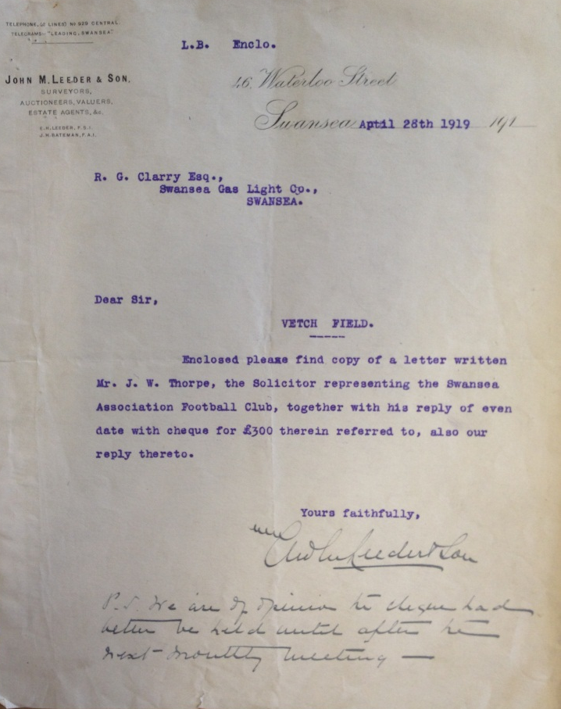
A large collection of material relating to Swansea Town’s leasing of the Vetch Field between 1912 and 1920. It is largely centred on the correspondence between the football club and the landlords of the ground, Swansea Gaslight Company, which spans several years and covers such issues as rent payments and sub-letting to schools and even the armed forces.
This series of letters highlights the financial predicament in which the club found itself, following the suspension of football during the First World War, a problem not unique to Swansea. Also included in this collection are receipts and agreements stating the amounts paid for rent, club income and expenditure. Breakdowns of the club’s financial activity for several seasons can be found in the annual reports, included in the file, which state the amounts earned and spent by the club in areas such as gate receipts and wages. In many of the letters and documents pre-dating the establishment of the club, the Vetch Field is referred to as ‘Fleming’s Meadow’. This collection is of particular significance as it contains some of the oldest documents related to the club.

Central Library Books on Swansea City FC
S 796. 334
- Tooze, Andrew & King, Martin, Swansea Jacks: Skinhead to Stone Island (Head-Hunter Books, 2007)
A look at a more controversial section of Swansea City’s Jack Army, those linked to football hooliganism. The book contains many first-hand accounts of their exploits from the late 1970’s up to the present day. The book covers football, fighting, fashion, politics and drug use among the firm. Although this section of football history is in many ways best left forgotten Swansea Jacks offers a valuable insight into the motivation for the group’s activities and the ways in which these activities changed as football policing, stewarding and stadia evolved to tackle the issue of hooliganism. Swansea City’s rivalry with Cardiff City is also covered in great depth and mentions some of the issues which divide the two Welsh clubs. The issues of politics are also heavily mentioned and cover a time of dramatic change in Britain from Margaret Thatcher to Tony Blair. Despite these positives, the book is taken from first-hand accounts which are limited in several ways; because of the nature of the topic there is a chance of exaggeration along with the possible consumption of drugs and alcohol blurring memories.
- Burgam, John, Swansea City FC (Manchester, Archive Publications Ltd, 1988)
A record of photographs and articles from the club’s own publications and The South Wales Evening Post. The book covers the club from its foundation in 1912 to the book’s publication in 1988. The clubs two most successful FA Cup runs in 1926 and 1964 when Swansea reached the semi-finals are covered as is the clubs meteoric rise up the Football League from the Fourth Division to First in just four years between 1977 and 1981. Despite this amazing achievement by 1986 the Swans were back in the Fourth Division after an equally rapid plummet down the Football League ladder. The book leaves Swansea in 1988 after the club had secured its future after being threatened by liquidation. The historical insight Swansea City FC offers is on the changing faces of the club’s players, Vetch Field and the City of Swansea as a whole. Ariel photographs of the Vetch show the change from industrial to residential and leisure, the marina had not yet been developed and the Tesco supermarket was still an area taken up by gas cylinders. Several old photos of the Vetch also show the change from largely uncovered terraces to covered terraces and seating areas.

- Haynes, Keith, Swansea 2010/11 Walking on Sunshine (Gloucestershire: The History Press, 2011)
-Haynes provides the story of Swansea City’s 2010/11 season in which they were promoted to the Premier League through a play-off final victory. As a dedicated Swansea fan, Haynes’s account is passionate and includes his own personal thoughts and experiences during the season.

- Grandin, Terry, Swansea City Seasons in the Sun 1981-82 and 1982-83 (Essex: Desert Island Books Ltd, 2005)
-Grandin tells the story of Swansea’s rapid rise from the Fourth to the First Division. In particular, he focuses on the two seasons (1981-82 and 1982-83) in which Swansea played in the First Division against top opposition such as Manchester United, Arsenal and Liverpool. Grandin also looks at Swansea’s meteoric rise under manager John Toshack who orchestrated three consecutive promotions and their dramatic fall to the bottom division.

- Trundle, Lee with Wathan, Chris, Lee Trundle More Than Just Tricks (Edinburgh: Mainstream Publishing Company 2010)
-Lee Trundle’s autobiography provides a revealing and honest insight into his upbringing in Liverpool, starting his career at non-league sides and his time at professional clubs including his beloved Swansea City. He also reflects on his personal life off the pitch.

- Sumbler, Phil & Haynes, Keith, Roger Freestone Another Day At the Office (Gloucestershire, Tempus Publishing Ltd, 2001)
-Haynes and Sumbler provide a biography of goalkeeper Roger Freestone’s life. The writers feel that Freestone is a dying breed of player who is loyal to the club compared to most modern players who aim to gain as much money as possible. As a result, they feel compelled to write the story of the respected ex-Swansea goalkeeper. The final chapter is written by Freestone himself who looks back at his success as a footballer.

- Jones, Colin, The Swans ‘Biography’ updated, Seven Seasons Updated Records 2000-2007 (Carmarthenshire: Dinefwr Publishers, 2007)
-A supplement to Professor David Farmer’s official ‘biography’ of the Swans featuring updated club records and statistics. There are also season reviews from 2000 to 2007.

- Farmer, David, Swansea City 1912-1982 (London: Pelton Books Ltd, 1982)
-David Farmer tells the full story up to 1982 of Swansea’s ups and downs. It includes the bankruptcy and re-election appeal in 1975, as well as the dramatic rise from the Fourth Division to the top flight under John Toshack. The book also contains appendices which will be useful for both statisticians and historians.

- Curtis, Alan with Johnson, Tim & Sprake, Stuart, Curt: The Alan Curtis Story (Edinburgh: Mainstream Publishing Company, 2009)
-An autobiography by footballer Alan Curtis who experienced the highs of Swansea’s rise through all four divisions. Curtis reflects his football career in which he played for Swansea during three different spells as well as coaching them. Curtis also writes about how much football has changed since his playing days.

- Farmer, David with contributions from Lili, Brian & Jones, Colin, The Official ‘Biography’ of the Swans Town & City (Swansea: South Wales Evening Post, 2000)
-Contains an extensive history of Swansea’s story from 1920 to 2000. There are also seventy three grids giving match statistics for each season in Football League and major cup competitions that includes results, teams, scorers etc.

Written by Jack Hankin, Grant Jenkins, Ben Mchardy, William Price and Michael Richards

